# ODE Modeling Exercises

## Exercise 4: ODE Modeling. Two reaction model (with simple regulation)

The goal of this exercise is to formulate and implement a simple kinetic model of two metabolic reactions (Figure 1) with and without regulatory interactions.

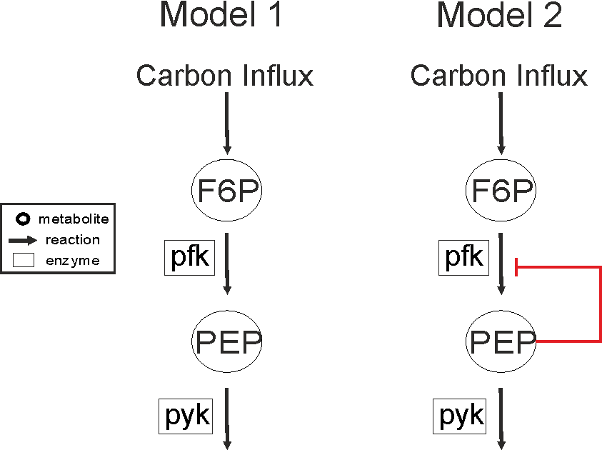

Figure : Reaction scheme of Model 1 and Model 2

**Pen and Paper Exercise: Set – up the two reaction model (Model 1)**

1. Based on the reaction scheme in Figure 1, write the Balance Equations for the species’ concentrations of **Model 1** under the assumption of Michaelis Menten kinetics and a constant Carbon Influx.
2. For **Model 1,** find the concentrations of species **F6P** and **PEP** in steady state, using the parameters from *Table 2*.

$Hint:In steady state, \frac{d[F6P]}{dt}=0 and \frac{d[PEP]}{dt}=0$

**Implementation and simulation of an ODE model (Model 1)**

1. Implement the resulting ODE system you described in the step 1) in MATLAB using the SimBiology toolbox:
   1. Use the provided “Model1.m” file as a basis and complete the code using the initial values of species concentrations and parameters from *Tables 1 and 2*.
   2. Simulate the dynamic behavior of the system for **10** seconds, using the default ODE solver. Plot the simulated concentration changes of the species in one graph. Do the steady state values of F6P and PEP agree with your calculations in the step 2)?
2. Change the initial amounts of the species concentrations to the values given in *Table 3*. Simulate the model and plot the concentration changes. Do the steady state values of the species change?
3. Analyze how the parameters KmPFK and VmaxPYK influence the behavior of the system. Perform parameter scan: for each of the two parameters, change its value in the range given in *Table 4*, and simulate the system behavior. To change the parameter value, you first have to get the parameter of interest in the following way:

*parameter = sbioselect(****modelObj1****,'Type','parameter','Where','Name','==',****'PARAMETER_NAME'****);*

where “**modelObj1**” is the model object you have created, and ***'PARAMETER_NAME’*** is the name of the parameter which values you want to change.

Plot the concentration changes of the two species for each parameter in a separate plot (4 plots in total). What happens to the steady state values of the species?

**Implementation and simulation of an ODE model with simple regulation (Model 2)**

1. Using the implementation of Model 1 from step 3) as a basis, implement Model 2 by adding the feedback mechanism. The non-competitive (allosteric) feedback inhibition of metabolite **PEP** on the reaction catalyzed by the enzyme ***pfk*** affects the maximum reaction rate of the enzyme. In order to include this regulation in Model 2, use a power law term $({\left[PEP\right]}^{a})$, where $a$ is a parameter describing the strength of the inhibition and its value can be found in *Table 2*.
2. Simulate Model 2 for **10** seconds and plot the simulated concentration changes of the species in one graph.
3. Compare the behavior of Model 1 and Model 2 in case of **step-like** **increase of the input**. Include the step-like input increase and simulate both systems for **200** seconds. Plot the simulated concentration changes of the species for each Model in a separate plot.

*To achieve a step – like input increase that happens after 40 seconds in simulation, include in your code the following command,* ***before simulating the system****:*

*addevent(modelObj1, 'time>= 40', {'Influx = 5'});*

1. Compare the behavior of Model 1 and Model 2 in case of a 40 second **pulse-like** **increase of the input.** Include the pulse-like increase of the input and simulate both systems for **200** seconds. Plot the simulated concentration changes of the species for each model in a separate plot.

*To achieve a pulse – like input increase that happens after 40 seconds in simulation and terminates after 80 seconds, include in your code the following commands,* ***before simulating the system****:*

*addevent(****modelObj1****, 'time>= 40', {'Influx = 5'});*

*addevent(modelObj1, 'time>= 80', {'Influx = 2'});*

1. Why would a biological system need to develop such a regulation mechanism?

Table 1: Initial values (mM)

|  |  |
| --- | --- |
| **Species Name** | **Initial Value** |
| F6P | 3 |
| PEP | 0.5 |

Table 2: Parameter values

|  |  |  |
| --- | --- | --- |
| **Parameter Name** | **Value** | **Unit** |
| Influx | 2 | mM / sec |
| KmPFK | 0.16 | mM |
| VmaxPFK | 5 | mM / sec |
| KmPYK | 0.31 | mM |
| VmaxPYK | 5 | mM / sec |
| a | -2 | unitless  (**to be used only for Model 2**) |

Table 3: (Alternative) Initial values (mM)

|  |  |  |
| --- | --- | --- |
| **#** | **Species Name** | **Initial Value** |
| **1** | F6P | 0.03 |
| PEP | 0.005 |
| **2** | F6P | 0.01 |
| PEP | 7 |
| **3** | F6P | 10 |
| PEP | 0.2 |
| **4** | F6P | 11 |
| PEP | 11 |

Table 4: Parameter ranges for parameter scan

|  |  |  |  |
| --- | --- | --- | --- |
| **#** | **Parameter Name** | **Value Range** | **Unit** |
| 1 | KmPFK | 0.16 – 5  (with a step of 0.1) | mM |
| 2 | VmaxPYK | 5 – 20  (with a step of 1) | mM / sec |